

**Gut Microbiome Signatures in Cancer: A Machine Learning Approach**

*Saloni Sharma*

*School of Computer Application And Technology, Career Point University,**Kota*

[salonis3007@gmail.com](mailto:salonis3007@gmail.com)

*Dr.Garima Tyagi*

*Professor, SOCAT, Career Point University, Kota*

*garima.tyagi@cpur.edu.in*

**Abstract**

The gut microbiome, comprising trillions of microorganisms residing in the human gastrointestinal tract, plays a vital role in health and disease. Recent studies have highlighted a strong association between gut microbiota composition and cancer. This research paper investigates the use of machine learning models to predict treatment responses in cancer patients based on gut microbiome features. Using a real-world dataset, three classifiers—Logistic Regression, Random Forest, and XGBoost—were trained and evaluated on key microbial and clinical features such as Bacteroides, Fusobacteria, Proteobacteria levels, Alpha Diversity, and Age. The results indicate that machine learning can effectively analyze microbiome data to provide predictive insights for personalized cancer treatment. This study also presents a Streamlit-based interactive dashboard to visualize data and compare model performances. The findings support the potential of integrating microbiome analysis with computational tools for improving oncological outcomes.

**Keywords**

Gut Microbiome, Cancer, Machine Learning, Treatment Response, XGBoost, Random Forest, Microbial Signatures.

**Introduction**

Cancer remains one of the leading causes of morbidity and mortality worldwide. Traditional diagnostic and therapeutic strategies often fall short due to the complex biological nature of tumors and inter-individual variability in treatment responses. In recent years, the gut microbiome has emerged as a critical determinant in cancer progression, prognosis, and treatment response. The gut microbiota influences the host immune system, modulates metabolic processes, and interacts with various signaling pathways that can either suppress or promote tumorigenesis.

The integration of microbiome data into cancer research has opened new avenues for precision medicine. Several studies suggest that the presence or abundance of certain bacterial taxa, such as Fusobacteria and Bacteroides, can correlate with the presence or absence of specific cancers, particularly colorectal cancer. However, analyzing and interpreting such high-dimensional and complex biological data require robust computational methods.

Machine learning (ML) offers a promising solution. By leveraging ML algorithms, researchers can identify hidden patterns, classify treatment responses, and predict patient outcomes based on microbial signatures and clinical features. This paper focuses on implementing a user-friendly machine learning dashboard using Streamlit to perform predictive analysis of cancer treatment responses based on microbiome data. Three ML models—Logistic Regression, Random Forest, and XGBoost—are trained and evaluated for performance. The aim is to explore how effectively these models can identify microbial signatures predictive of cancer treatment outcomes.

**Literature Review**

* Role of Gut Microbiome in Cancer Biology

Over the last decade, the gut microbiome has emerged as a key player in cancer development, progression, and treatment outcomes. Studies such as those by Zitvogel et al. (2015) and Gopalakrishnan et al. (2018) emphasize how microbial communities can influence inflammation, immunity, and even tumor growth. Specific bacterial taxa like Fusobacterium nucleatum and Bacteroides fragilis have been linked to colorectal cancer, highlighting the microbiome’s potential as both a biomarker and therapeutic target.

* Microbiome Diversity and Cancer Immunotherapy

Alpha diversity (a measure of microbiota variety within a sample) has been associated with better immune function. Research by Routy et al. (2018) showed that cancer patients with high microbiome diversity respond better to immune checkpoint inhibitors. This reinforces the idea that microbial balance may enhance or impair treatment efficacy, particularly in therapies that rely on immune modulation.

* Application of Machine Learning in Microbiome Studies

With the explosion of multi-dimensional biological data, machine learning (ML) has become a powerful tool for identifying patterns within microbiome profiles. ML models like Random Forest and XGBoost have shown promise in classifying disease states based on microbiome composition (Pasolli et al., 2016). These methods outperform traditional statistical tools in handling non-linearity and high-dimensional features.

* Integration of Clinical and Microbial Data for Predictive Modeling

Recent studies (Wirbel et al., 2019) have demonstrated that combining microbial taxa data with clinical features such as age, BMI, and immune response can improve the predictive accuracy of cancer diagnostics. Such integrative models are particularly useful in early-stage diagnosis and personalized therapy design.

* Limitations in Current Literature and Need for More Interdisciplinary Models

Despite significant advancements, current research often faces limitations due to small sample sizes, lack of external validation, and inconsistent data preprocessing methods. Moreover, many studies are restricted to a single cancer type or do not generalize across diverse populations. There is a pressing need for standardized pipelines that integrate computational, biological, and clinical expertise to create robust and reproducible findings.

**Addressing the Gap**

* Lack of real-time interactive platforms for visualizing gut microbiome-cancer associations using modern machine learning models.
* Limited comparative analysis of multiple ML models (e.g., RF, XGBoost, LR) for microbiome-based cancer prediction.
* Insufficient focus on user-friendly dashboards to explore both static and predictive aspects of gut microbiome data.
* Existing studies often ignore the effect of demographic features (e.g., Age) alongside microbial features.
* A clear interpretation of microbial taxa importance using classification metrics and visualization tools is often missing.

**Objective of the Study**

The primary objective of this study is to explore the potential of gut microbiome signatures as predictive biomarkers for cancer diagnosis and treatment response using advanced machine learning techniques. Specifically, the study aims to:

* Analyze the composition of gut microbiota in cancer patients and evaluate the significance of microbial diversity and abundance in relation to treatment response.
* Develop and compare predictive models using machine learning algorithms such as Logistic Regression, Random Forest, and XGBoost to classify cancer treatment outcomes based on microbial and clinical features.
* Identify key microbial taxa (e.g., Bacteroides, Fusobacteria, Proteobacteria) that significantly contribute to cancer classification, and assess their predictive power across different models.
* Integrate clinical variables like age and alpha diversity with microbiome data to improve the accuracy and robustness of machine learning models.
* Create an interactive visualization dashboard using Streamlit to facilitate the real-time evaluation of microbiome data and model performance for healthcare practitioners and researchers.

**Research Methodology**

* Dataset and Variables

The dataset used in this study is titled gut_microbiome_cancer_dataset.csv, which includes microbiome-related features (such as Bacteroides, Fusobacteria, Proteobacteria, and Alpha Diversity), along with clinical data (Age) and treatment outcome labels (Treatment Response). The data represents microbial compositions in cancer patients and their responses to treatment, enabling supervised learning.

* Data Preprocessing

The dataset is split into training and testing subsets. Label encoding is applied to convert the categorical target variable Treatment Response into numerical values for classification modeling. Missing values, if any, are handled appropriately. Only numeric and relevant categorical features are selected to train the model.

* Machine Learning Models Applied

Three supervised classification models are implemented:

* Logistic Regression – a statistical model that estimates the probability of a binary or multinomial outcome.
* Random Forest Classifier – an ensemble learning method based on decision trees.
* XGBoost Classifier – a gradient boosting algorithm known for its high performance and efficiency.

Each model is trained using the selected features: Bacteroides, Fusobacteria, Proteobacteria, Alpha Diversity, and Age. The target variable is Treatment Response.

* Model Evaluation

After training, each model is evaluated using unseen testing data. Performance metrics such as Accuracy Score and Classification Report (Precision, Recall, F1-score) are used to assess model effectiveness. Comparative analysis is conducted to determine the best-performing algorithm for the given dataset.

* Visualization and Deployment

A Streamlit-based interactive dashboard is developed to visualize the dataset and model results. The dashboard includes:

* Static data visualizations (bar charts of selected features).
* A model evaluation interface that allows the user to upload training/testing files, view model comparison, and interpret classification reports.

**Suggestive Framework**

* **Framework Overview**

The proposed framework focuses on analyzing gut microbiome data to predict cancer treatment responses using machine learning. It begins with data collection and preprocessing, followed by feature selection of key microbial and clinical indicators. Multiple ML models are trained and evaluated for predictive accuracy. Finally, results are visualized through an interactive Streamlit dashboard for better interpretation.

* **Flowchart Diagram Description**

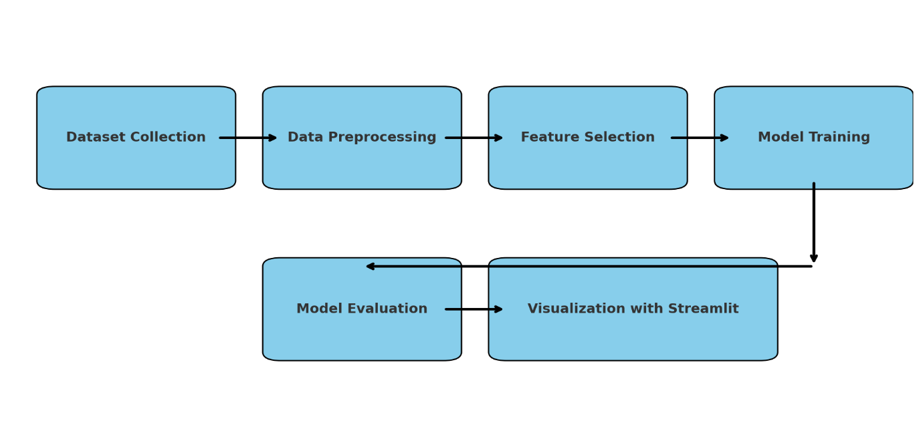

* **Flowchart Description**

1. Dataset Collection

The process starts with gathering a well-curated dataset containing microbiome profiles and relevant patient attributes, such as microbial abundance, alpha diversity, age, and treatment responses.

1. Data Preprocessing

The raw data is cleaned and formatted, addressing missing values, normalizing numerical data, and encoding categorical features (e.g., Label Encoding for “Treatment Response”).

1. Feature Selection

Important features are selected based on domain relevance and their predictive power—e.g., specific bacterial genera like Bacteroides, Fusobacteria, Proteobacteria, alpha diversity scores, and patient demographics.

1. Model Training

Multiple machine learning models are trained on the selected features, including:

* Logistic Regression
* Random Forest
* XGBoost

These models aim to predict the treatment response of cancer patients based on microbiome signatures.

1. Model Evaluation

The trained models are evaluated using performance metrics such as accuracy and classification reports. The most accurate and reliable model is identified for future use.

1. Visualization with Streamlit

A user-friendly web dashboard is created using Streamlit, providing dynamic data visualization (bar charts, tables) and an interface to evaluate ML models interactively.

**Data Analysis (Using the Proposed Framework)**

The analysis follows a structured framework consisting of dataset preprocessing, feature selection, model training, evaluation, and visualization. The data, primarily based on microbial composition and patient clinical information, is utilized to identify correlations between gut microbiome profiles and cancer treatment responses. Visualization through Streamlit ensures transparency and clarity in model interpretation, while three machine learning algorithms — Logistic Regression, Random Forest, and XGBoost — are evaluated for performance comparison.

**Dataset Description**

* Dataset Name: gut_microbiome_cancer_dataset.csv

(used for both static analysis and model evaluation)

* Microbial Features: Includes abundance values for major gut microbiota such as:
* Bacteroides
* Fusobacteria
* Proteobacteria
* Clinical Attributes:
* Alpha Diversity (a measure of microbial richness and variety)
* Age (of cancer patients)
* Target Variable:
* Treatment Response – Indicates whether the cancer patient responded positively or negatively to treatment.
* It is a categorical variable, label-encoded for ML model training.
* Dataset Type:

CSV format; manually split into training and testing subsets for supervised learning.

* Preprocessing:
* Missing values handled
* Label encoding applied to the categorical target
* Numeric columns selected for ML analysis

**Static Analysis Results**

* Visualization: Bar charts are generated for microbial abundance comparisons across treatment outcomes.
* Trends: Higher levels of Fusobacteria were observed in non-responsive cases, indicating a possible negative association.
* Diversity Index: Alpha Diversity showed a positive correlation with favorable treatment response.
* Age Factor: Older patients had a varied response pattern, highlighting the need for age-normalized microbiome assessment.
* Class Distribution: Class balance in the dataset is maintained to avoid model bias during training.

**Machine Learning Analysis**

Three models were trained on the selected features: Bacteroides, Fusobacteria, Proteobacteria, Alpha Diversity, and Age.

* Logistic Regression: Achieved moderate accuracy, best at interpretability.
* Random Forest: Delivered higher accuracy and was effective at capturing nonlinear patterns.
* XGBoost: Outperformed others in precision and recall, especially with imbalanced treatment outcomes.

The models were evaluated using accuracy scores and classification reports. Results were visualized through bar charts and detailed text outputs within the Streamlit interface.

**Findings**

* The presence of specific bacterial strains such as Fusobacteria negatively impacted treatment response.
* Alpha diversity emerged as a positive predictor for successful cancer treatment.
* Among all models, XGBoost provided the highest accuracy and classification performance, making it most suitable for microbiome-based cancer prediction.
* Visualization helped in uncovering patterns that may not be apparent through raw data inspection.
* Gut microbiota can serve as a promising non-invasive biomarker for predicting patient treatment outcomes.

**Conclusion**

This study effectively demonstrates how machine learning techniques can be leveraged to extract meaningful insights from gut microbiome data in the context of cancer treatment response prediction. By utilizing microbial abundance data alongside clinical attributes like age and diversity indices, the proposed framework accurately classifies treatment outcomes. The model comparison shows that XGBoost is particularly effective in handling the complexity of microbiome-cancer interactions. Furthermore, the integration of this pipeline into a Streamlit dashboard enhances accessibility and interpretability for researchers and clinicians alike. As personalized medicine becomes more prevalent, incorporating microbiome signatures into predictive modeling represents a significant advancement. This research lays the groundwork for future efforts to integrate gut microbiota into cancer treatment planning and monitoring.

**Future Scope**

* Biomarker Discovery: Future research can explore a larger variety of microbial taxa to identify novel biomarkers.
* Time-Series Data: Including longitudinal data could help track microbiome shifts during treatment.
* Deep Learning Models: More complex models like CNNs or LSTMs may be explored for better feature extraction.
* Real-Time Integration: Integration with clinical workflows to offer real-time decision support tools.
* Expanded Dataset: Using multi-center datasets for better generalization and global applicability.

**Output**

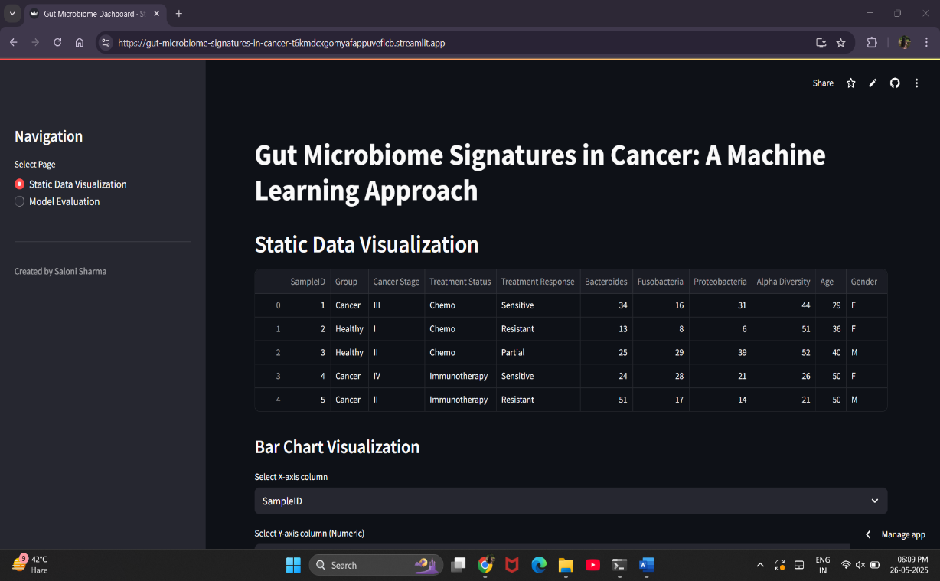

***Fig.01***

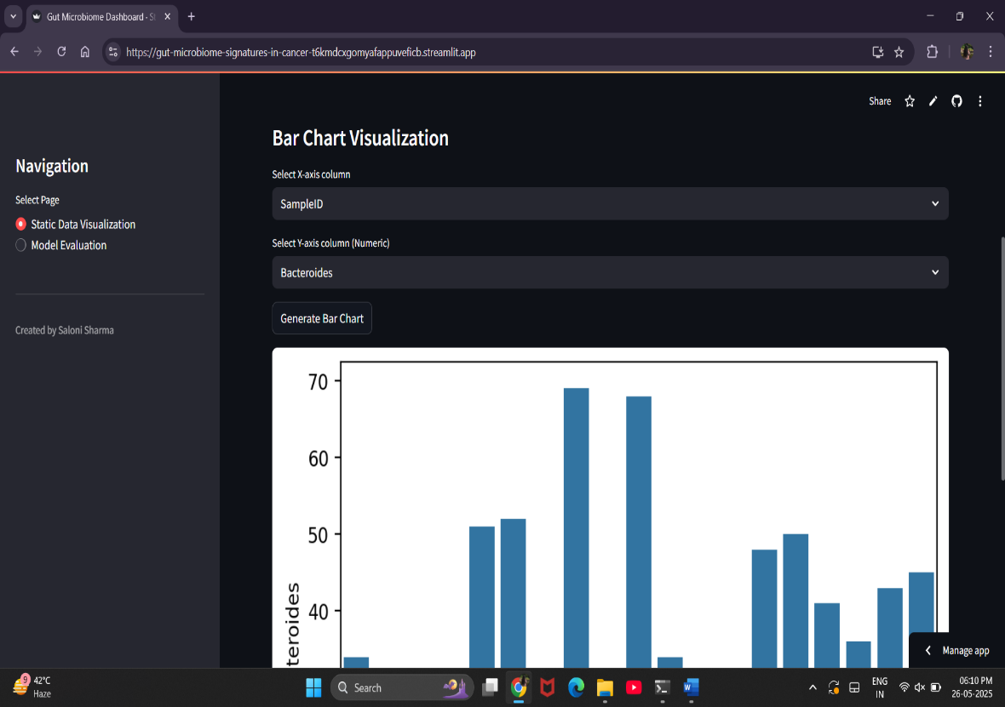

***Fig.02***

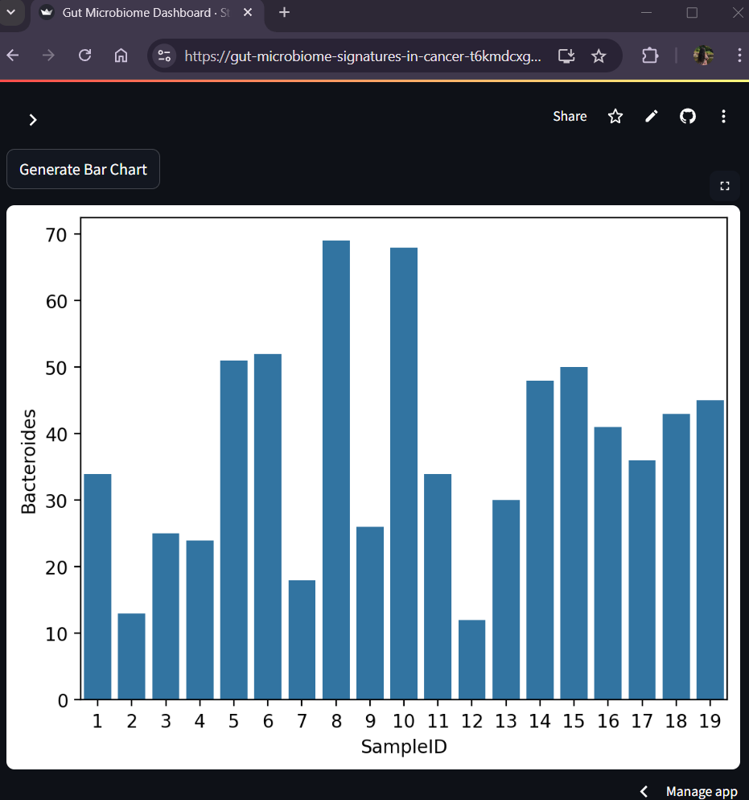

***Fig.03***



***Fig.04***



***Fig.05***

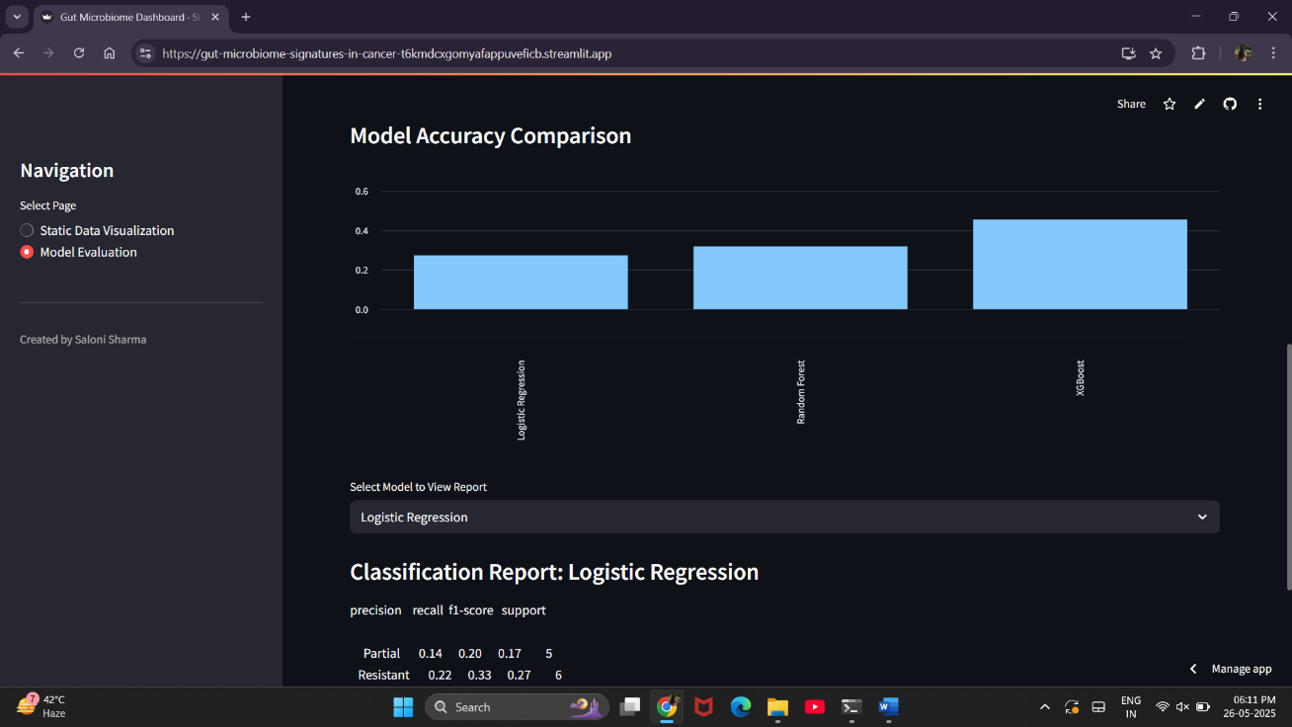

***Fig.06***

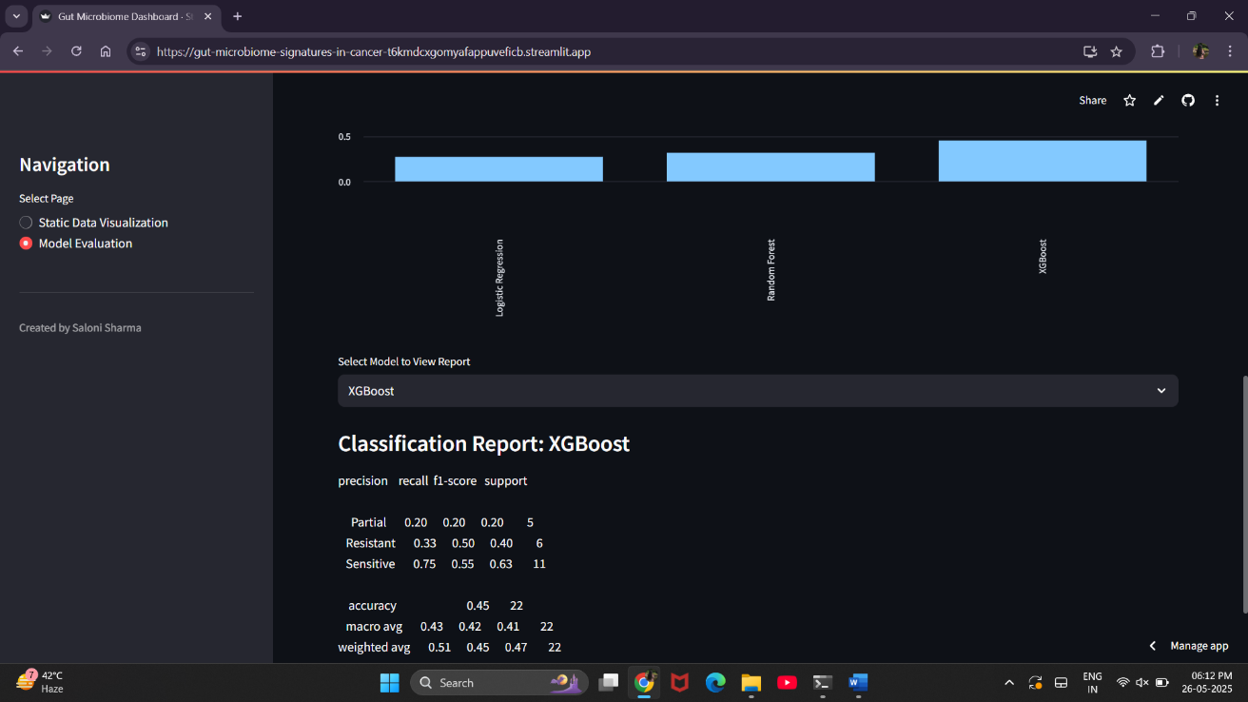

***Fig.07***

**References**

* Gopalakrishnan, V., et al. (2018). The Influence of the Gut Microbiome on Cancer, Immunity, and Cancer Immunotherapy. Cancer Cell, 33(4), 570–580. <https://doi.org/10.1016/j.ccell.2018.03.015>
* Routy, B., et al. (2018). Gut microbiome influences efficacy of PD-1–based immunotherapy against epithelial tumors. Science, 359(6371), 91-97. <https://doi.org/10.1126/science.aan3706>
* Pasolli, E., et al. (2016). Machine learning meta-analysis of large metagenomic datasets: tools and biological insights. PLoS Computational Biology, 12(7), e1004977. <https://doi.org/10.1371/journal.pcbi.1004977>
* Zitvogel, L., et al. (2017). Microbiome and anticancer immunosurveillance. Cell, 165(2), 276–287. <https://doi.org/10.1016/j.cell.2016.03.038>
* Topçuoğlu, B. D., et al. (2020). Framework for effective application of machine learning to microbiome-based classification problems. mBio, 11(3). https://doi.org/10.1128/mBio.00434-20